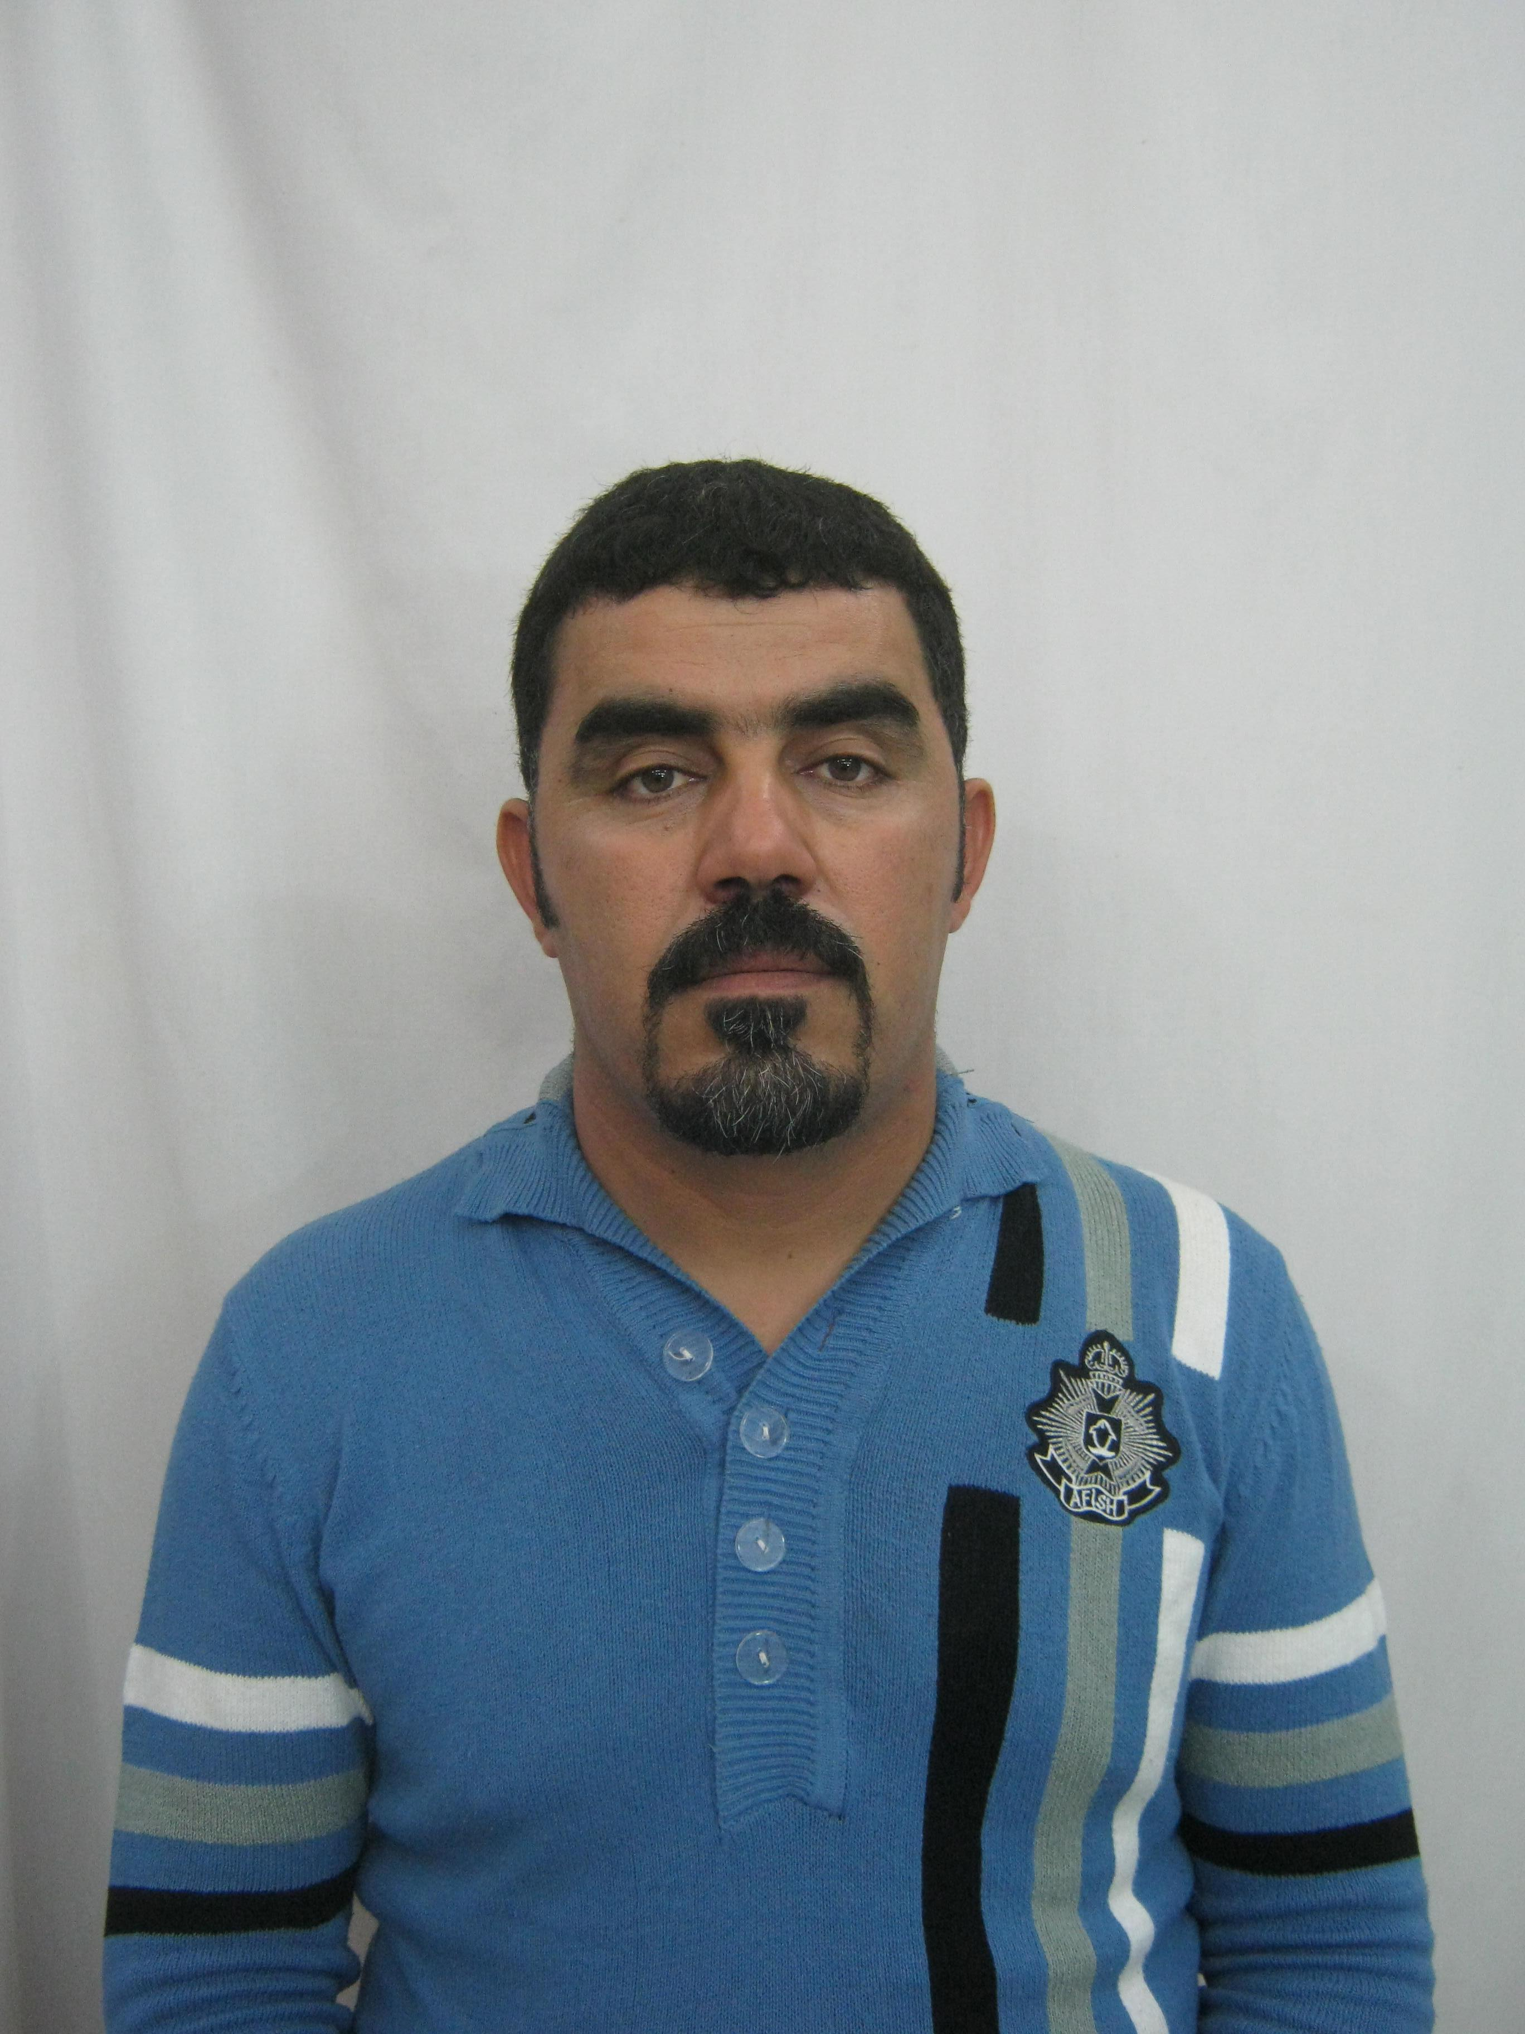

Curriculum Vitae
DAHNOUN RACHID NIGHT- TOOLPUSHER
Date of Birth: 27 may 1974 Nationality: Algerian

.
Contact Details adress:street saoudi kouider sidi khaled
. biskra.algeria
Home Tel: +213 33679341
Mobile: +213 662144327
E-mail : rdahnoun@ymail.com
Skype: rachid.dahnoun2

Experience: Apr 2017 - Present: Toolpusher Weatherford ( WDI ) Algeria.
feb 2015 –Apr 2017: Toolpusher John Energy Ltd Algeria.

Nov 2014 – feb 2015: Toolpusher Sakson Egypt Company Algeria.
Jan 2013 – Nov 2014: Toolpusher NDIL Company(Nabors)Algeria.
Dec 2012 - Jan 2013: Driller NDIL Company(Nabors) Algeria.
Sep 2012 – Dec 2012: Driller John Energy Ltd Algeria.
2011 – Sep 2012: Driller NDIL Company(Nabors)
2008 - 2011: Driller National Drilling Company (Enafor) Algeria.
2006 - 2008: Assistant Driller National Drilling Company (Enafor) Algeria.
2005 - 2006: Assistant Driller Trainee National Drilling Company (Enafor) Algeria.
2002 - 2005 Derrickman:National Drilling Company(Enafor),Algeria.
Certificates: - Stuck Pipe Prevention
- IADC Hse Rig Pass Land/Offshore
- Basic First Aid
- Hse Leadership
- Harassment Prevention Training For Supervisors
- Advanced Safety Audit (ASA)
- Hydrogen Sulfide (H2S) Training
- Fire Protection & Prevention Awareness
- JSA Training
- Pace Training
- IWCF Supervisor level: Expire in Jan 2019 certificate
Computer Skills: - knowledge of Microsoft Office and Windows Programs
- CAO and CFAO Good skills (Solid Works)
- Linux System; Open Office Applications.
- Hardware and Software Understanding
Languages: French: little
English: little
Arabic: Fluent

Other Information: - Driving License
- Passport

Oil Field Skills: Experience of 16 years with Land Rigs and Rigs Operations managing. Familiar with differents rigs calculations and parameters optimizations and well bore stability. Experience in Gas well, Oil Well , vertical and horizontal to 20 000 feet Depth . Good, extensive and strong experience with all types of TDS and Rigs - Canrig, Varco ,Tesco,Nov ( 500 Tons ), and Ideal Rigs Semi Joystick NOV and ( Hydraulic and Electrical ) , Joystick – Cyber chair Touch screen- and new generation of Drilling Rigs as HH( HONG HUA) and Bomco Rigs-E lectrical System(SCR , VFD – PLC System, ADS ),. Experience in Drilling with HP and High Temperature as Deep Wells . Familiar with well control situations and remedial as : Well fishing operations, side truck, perforating, DST ( Well Testing ), Coil Tubing, and more. Well versed with running long string of Casing and Cementing with multistage ( using DV Tool for multistage cementing ). Experience in Horizontal Drilling Conventional & New System With Auto Track 90° - and Drilling with lost circulation ( total losses ).
- Top Drive Drilling Mode qualification -Canrig 500Tons - Tesco 500Tons
Varco 500Tons. NOV 500Tons.
- Handling brake Drawworks National E 2000hp-E1500hp-E 840 & Ideco 2000hp
- joystick (Cyber Chair )Drawworks Bomco-2000hp & HH JC50-1500hp
HH JC70-2000hp
- Oil and gas wells drilling calculations
- Geological knowledge
- Logging knowledge
- Cements jobs knowledge
- Rig Move (heavy and ultra heavy land rigs)
- Rigging and handling
- Personal and Rig management

Hobbies: - Drilling calculations under Microsoft Excel
- Drilling soft wares
- Oil Field Magazines
- Tourism and Photography
- Internet Surfing

